**Gem Matching**

In this assignment, you will be creating a Gem Matching game. Your job is to write two support classes used by the game. You will be implementing a linked list and using an enumerated type.

*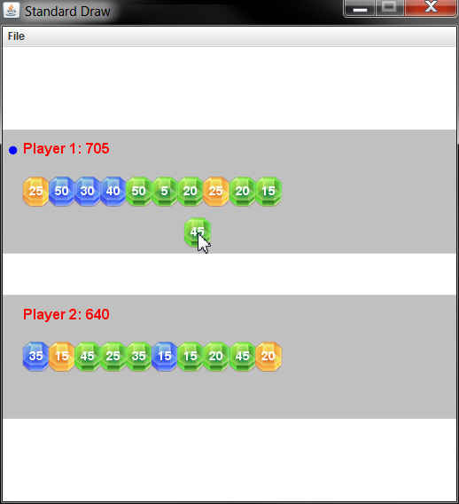****Gem Matching*.** The game is played by two players who take turns placing a gem. Each new gem is randomly one of three different colors and has a random point value. A player may place a gem in their own row of gems to increase their score. A player may also place a gem in their opponent's row to break up a gem *block*. A *block* is any group of consecutive gems of the same color.   
  
A player's score is the sum of the point total of all gems in their row. Blocks in a player's row incur a score multiplier. The score multiplier is the number of gems in the block. For example, a block of three green gems with point values 10, 20, and 30 would earn 3 * (10 + 20 + 30) = 180 points. See [here](https://youtu.be/9jGON2bgKMw) for a short demo of how the game works.

Due to multipliers, it can sometimes be advantageous to give a gem to your opponent since you can use it to break up a block. The game ends when either player hits 16 total gems; the player with the higher score wins.  
  
***Files*.** The lab folder contains the three image files for green, blue and orange gems. It also contains three Java classes. You have been given a completely finished version of GemGame.java. You will be implementing the two support classes Gem.java and GemList.java.   
  
***Gem*.** The Gem class represents a single gem in the game. It knows things like its color (green, blue, or orange) and its point value. You should use the provided ***enumerated type*** (more info in lab folder) to represent the color of a gem. A new gem is assigned one of the three colors at random. The point value of a gem is a random value in the set {0, 5, 10, 15, 20, 25, 30, 35, 40, 45, 50}.

Using the StdDraw class, Gems are drawn first using one of the image files **"gem_green.png"**, **"gem_blue.png"**, or **"gem_orange.png"**. The point value is then drawn in a white text over the image.   
  
Here is the API you should implement for the Gem class:

class Gem

---------------------------------------------------------------------------------------------------

Gem() // create a gem with random color and point value

Gem(GemType type, int points) // create a gem with the specified color and point value

String toString() // return a string representation of the gem

GemType getType() // get the type of the gem

int getPoints() // get point value of the gem

void draw(double x, double y) // draw gem at (x, y) using StdDraw's methods (**see docs/FAQ**)

A number of tests inside a main method have been provided; feel free to add more as you see fit. You should see the console and StdDraw output shown below. **NOTE:** the row of 16 gems is using the default constructor (that creates a random gem), so you are unlikely to get the same thing!

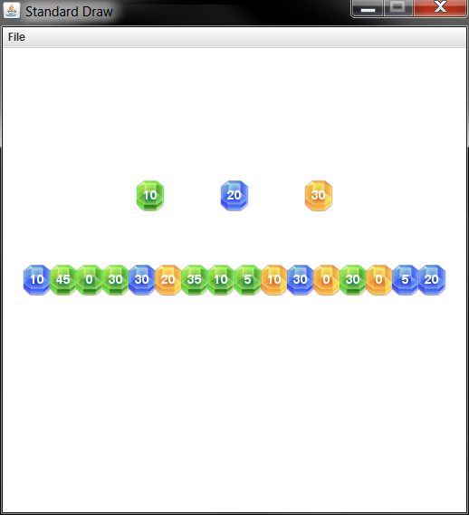

**Console output:**

GREEN 10, GREEN, 10

BLUE 20, BLUE, 20

ORANGE 30, ORANGE, 30

***GemList*.** The GemList class represents all the gems held by a player, as well as their order. The class allows new gems to be inserted anywhere in the list by specifying the integer index of the gem to insert before. You are required to implement this using a *linked list* data structure you create. Each Node in the linked list will contain a Gem and a reference to the next Node in the list. Within GemList.java, define a nested class Node in the standard way:

private class Node

{

private Gem gem;

private Node next;

}

Your GemList data type must implement the following API (see the **FAQ** for more help):

class GemList

---------------------------------------------------------------------------------------------------

int size() // return the number of gems in the list

void draw(double y) // draw all gems in the list at the given Y-coordinate

void draw(double y) // see **FAQ** for help drawing gems at a particular loc.

String toString() // return a string representation of the list

void insertBefore(Gem gem, int index) // insert the given gem *before* the 0-based index

// if index is >= size, the new gem is inserted at end

int score() // calculate the total score of the list

As mentioned previously, to score a list of gems, you need to apply score multipliers for any blocks of gems of the same color. Given the following Gem list:

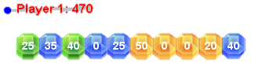

This gem list would be scored as follows:

* First block one green gem, 25 = 1 * (25)
* Second block one blue gem, 35 = 1 * (35)
* Third block one green gem, 40 = 1 * (40)
* Fourth block two blue gems, 50 = 2 * (0 + 25)
* Fifth block four yellow gems, 280 = 4 * (50 + 0 + 0 + 20)
* Sixth block one blue gem, 40 = 1 * (40)
* **Total 470 (25 + 35 + 40 + 50 + 280 + 40)**

A main method containing various tests has been provided; feel free to add tests as you see fit. Here is the console and StdDraw output from our program:

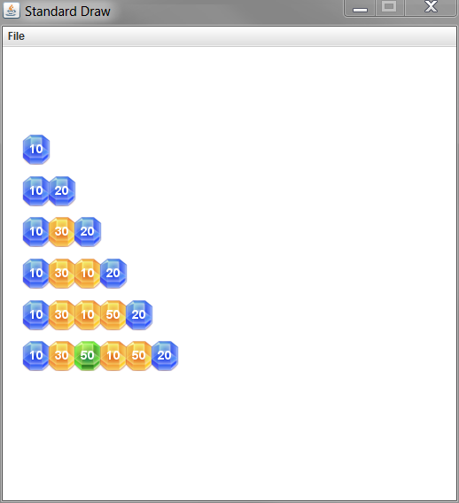

**Console output:**

<none>

size = 0, score = 0

BLUE

size = 1, score = 10

BLUE -> BLUE

size = 2, score = 60

BLUE -> ORANGE -> BLUE

size = 3, score = 60

BLUE -> ORANGE -> ORANGE -> BLUE

size = 4, score = 110

BLUE -> ORANGE -> ORANGE -> ORANGE -> BLUE

size = 5, score = 300

BLUE -> ORANGE -> GREEN -> ORANGE -> ORANGE -> BLUE

size = 6, score = 230

**(Advanced) Game improvements**

Have some time and want to make a better game? Try the following:

* Create a new version of the game in which the second player is the computer. When it is the computer's turn, it should evaluate the best possible location to put the gem. It should maximize the difference between the computer's score and the human's score.
  + You'll probably want to implement a method in your GemList class that lets you delete an item at a specific index. This will allow you to temporarily insert the current gem into all possible locations in both players' gem lists.
* Make the game more interesting by adding additional types of playing pieces. For example, there could be a *bomb* piece that can be used to blow up part of your opponent's row. Other ideas would be a *wildcard* piece that matches any color or that increases a block's score multiplier.
* Change the game so you only score points when you make a run of so many gems. Once a run is made, the gems blow up and the player scores points based on the gems in the run. This will make the game continue as long as both players are able to complete runs to free up space in their gem row.

***Gem Matching*** *project from*

*https://katie.mtech.edu/classes/csci135-online/assign/gem/*